**Background.** Variation in the strength and direction of natural selection through time is a ubiquitous feature across the tree of life (Bell 2010). In response to temporal fluctuations in selection pressure, populations of many species - particularly those with short generation times - are predicted to adaptively evolve as they track along a moving fitness landscape (Botero *et al.* 2015). Although adaptive tracking is likely a ubiquitous evolutionary process, we have a limited understanding of its prevalence and its effects on patterns of genetic diversity. Genomic signals of adaptive evolution in response to temporally fluctuating selection pressure are limited, particularly for wild populations (Bergland *et al.* 2014; Campbell-Staton *et al.* 2017; Nosil *et al.* 2018), often preventing us from relating empirical and expected patterns of diversity. **To advance our understanding of the temporal dynamics of evolution, my lab studies the genetic signatures and genomic consequences of rapid evolution in response to seasonal fluctuations in selection pressure.**

My research focuses on the seasonal dynamics of evolutionary change in short-lived organisms with multiple generations per year. For such species, the environment changes rapidly from one generation to the next, and populations can cyclically evolve over annual time-scales. **The cyclic nature of seasonal evolution allows us to address a number of basic questions as they unfold**: Is short-term evolution repeatable or predictable at a molecular level? Is temporally fluctuating selection a major evolutionary force that promotes genetic diversity? What are the relative contributions of short-term demographic events versus adaptation in contributing to seasonal changes in the genetic composition of populations? Which traits are subject to seasonally varying selection and what is the genetic architecture of rapid adaptation in the wild? To address these questions, we focus on two study systems, *Drosophila melanogaster* and *Daphnia pulex*.

Populations of *D. melanogaster* living in orchards throughout the world adaptively track in response to seasonal fluctuations in selection pressure (e.g., temperature), over the course of 10-15 generations. These wild populations also harbor extensive genetic variation in an array of ecologically relevant, fitness related traits(Schmidt & Conde 2009; Adrion *et al.* 2015; Mackay & Huang 2018). Genetic variation in starvation tolerance, thermal tolerance, longevity, fecundity, etc., enables some individuals to be more likely to survive winter, and others better able to exploit the favorable growing season (Schmidt *et al.* 2005; Behrman *et al.* 2015; Rajpurohit *et al.* 2017; Behrman *et al.* 2018). Genetically based seasonal variation in phenotype is generated by polymorphisms that fluctuate in frequency between seasons (Cogni *et al.* 2014; Paaby *et al.* 2014). Work in my lab seeks to (1) document genetic variation across time and space in *Drosophila* and to use genomic data to infer evolutionary dynamics of natural populations; and, (2) to uncover the genetic architecture, molecular function, and evolutionary history of polymorphisms that underlie local adaptation.

*Daphnia pulex* are an ideal system to study the temporal dynamics of evolutionary change. Clonal isolates of *D. pulex* sampled within and among ponds (Reger *et al.* 2018), and across seasons (Pfrender & Lynch 2000), show extensive genetic variation in life-history traits, predator defense capacity, and sexual dynamics. The presence of variation within populations is somewhat surprising, given the seasonal dynamics of *D. pulex* living in small semi-ephemeral ponds. The classic view of such populations is that daphnia hatch in the spring from resting eggs, which are the product of sex the at the end of the previous growing season; these newly hatched daphnia then undergo asexual reproduction and clonal selection, leading to a rapid decline of clonal diversity; sex ensues and the population overwinters as resting eggs (or over-summers in areas where summer drying is the selective agent). In the absence of a diversifying force, such a population would quickly become monomorphic and highly inbred. Contrary to this prediction, the populations that we study are surprisingly diverse at both a molecular and phenotypic level. To assess the importance of different diversifying forces on the maintenance and generation of variation, we study the temporal dynamics of clonal evolution and sex in wild populations, and work to identify the forces that maintain polymorphism.

**Key gaps in our understanding.** In my view, a major gap in our understanding of evolutionary biology is knowledge about the prevalence of adaptive tracking over short time-scales. Because of this empirical deficiency, we are unable to test basic models that predict the consequences of fluctuating selection and adaptive tracking on patterns of genetic diversity at functional and linked sites (Huerta-Sanchez *et al.* 2008; Cvijović *et al.* 2015; Park & Kim 2019). There are at least two reasons for this major gap: First, as a field we have historically lacked access to temporally sampled genomic datasets of wild populations. Second, quantitative life-history and behavioral traits are likely the primary targets of temporally fluctuating selection (Siepielski *et al.* 2009); therefore, identifying loci underlying adaptive tracking as a means to study evolutionary dynamics over short time-scales is technically challenging. To address these historical and technical challenges, my research program has developed long-term genomic monitoring of natural populations for two species and has developed innovative approaches to mapping quantitative traits in outbred populations.

Is adaptive tracking to fluctuating selection pressures an important phenomenon in general? The answer is yes, but the relative importance likely varies dramatically across taxa. Fundamentally, the importance of adaptive tracking is a function of grain size (Levins 1968) - the pace of environmental change relative to generation time. Organisms with short generation times are likely to exhibit adaptive tracking; those with longer generation time evolve plasticity (Botero *et al.* 2015). Variation in the relative importance of adaptive tracking across taxanomic groups may contribute to the generation time effect on the rate of adaptive substitution (Cvijović *et al.* 2015; Thomas *et al.* 2010). While it is therefore reasonable to claim that adaptive tracking must affect all species, to some extent, how much of the genome is subject to adaptive tracking, and the strength of fluctuating selection, remain largely unknown (but see (Machado *et al.* 2018; Buffalo & Coop 2020).

Whether adaptive tracking promotes long-lived, balanced polymorphisms is another fundamental mystery. Theoretical models are somewhat conflicted in their predictions (Hedrick 2006), but models that incorporate storage mechanisms such as seed banks (Turelli *et al.* 2001), age-structure (Ellner & Hairston 2015), or aspects of genetic architecture (Wittmann *et al.* 2017; Bertram & Masel 2019), typically show that long-lived balanced polymorphism can exist. If these ecologically relevant polymorphisms segregate at intermediate frequencies for long periods of time, they may have a limited effect on patterns of neutral variation (Charlesworth 2006; Gao *et al.* 2015). These models present a paradox: the stronger the stabilizing force associated with temporally varying selection, the less it contributes to linked polymorphism and, by extension, the less apparent its signal in genome-wide scans. Work proposed here seeks to address this issue through the use of experimental quantitative genetic approaches (Drosophila) and pedigree-based analysis (Daphnia).

**Recent Progress**. The goal of the previous funding period was to identify loci underlying natural genetic variation in seasonally selected traits. Because these loci are enriched for `true positives`, we can use them to ask basic questions about the temporal dynamics of adaptive tracking, and its consequences on patterns of genomic variation at linked sites. We have pursued this basic question using two species, with the goal of making a more general statement about the extent of balancing selection operating via temporal variation in selection pressures; and to contrast the roles of obligate- and facultative sex on the dynamics and consequences of balancing selection.

***Drosophila***. To study the evolutionary dynamics of seasonal adaptation in Drosophila, my lab has sought to map natural genetic variation in fitness-related traits, and to apply those data to surveys of allele frequency fluctuations across space and time. Our work has focused on various aspects of overwintering stress tolerance, with particular attention to aspects of thermal- and nutritional-stress (Stone *et al.* 2020). We situate our work in both a laboratory and a field-based context, allowing us to experimentally disentangle environmental and genetic contributions to phenotypic variation.

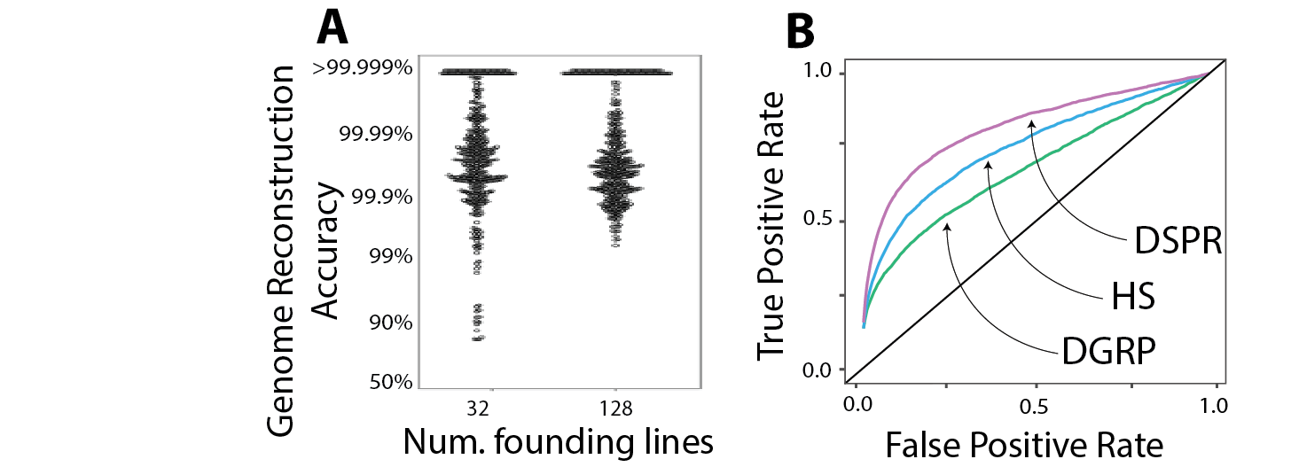

**Figure 1.** (A) Fully phased genomes can be reconstructed accurately for HybridSwarm (HS) crosses with large numbers of founding lines (results show simulated F5 swarms). (B) Receiver-operator curve for simulate GWAS (10 loci, small effect sizes) using different mapping panels (8-way DSPR; 128 DGRP inbred lines). Inbred panels like the DGRP can exhibit high false positive rate; RILs such as the DSPR have high power, but are limited to the existing founders. The HybridSwarm is an attractive alternative, opening new experimental avenues.

To study the genetic architecture of overwintering traits, we (Weller & Bergland 2019) have developed a mapping protocol that utilizes outbred multi-parental populations. The motivation for this approach is three-fold: (1) it enables mapping across a range of environmental conditions, and (2) it facilitates the generation of mapping-populations with different genetic backgrounds, and (3) it alleviates some issues of high false positive rates which occur when using inbred panels. In this approach, a moderate number of founder lines (ca. 10-100) are intercrossed for ~5 generations as an outbred population, maintained in large population cages (N~50,000). Individuals are then phenotyped and genotyped for subsequent genome-wide association analysis. We developed a pipeline for reconstructing fully phased genomes from ~0.05X sequencing (~$6-7/individual, which includes DNA extraction, library prep, and sequencing). Genome-reconstruction achieves high accuracy (>99.9%, Fig 1A) and is scalable in the number of founders. The practical utility of this approach is that individuals from large, panmictic populations can be distributed across environments, alleviating a substantial amount of vial-effects and the logistical burden of exposing hundreds- to thousands of lines to a large number of environmental treatments. In addition, mapping populations can be constructed from lines (either inbred or outbred) collected across the geographic range, or through time, enabling mapping experiments to reflect the range of variation within the species.

We evaluated the power and precision of association mapping using this approach (which we call a Hybrid Swarm), relative to other experimental mapping designs (recombinant inbred lines, e.g. DSPR - Long *et al.* 2014; inbred lines, e.g. DGRP - Mackay *et al.* 2012). We find that the Hybrid Swarm approach has a lower false positive rate than inbred lines, likely due to recombination breaking up long-distance linkage-disequilibrium (Nuzhdin & Turner 2013). Like all outbred mapping designs, the Hybrid Swarm suffers a loss of power, at the true locus, relative to inbred lines via the absence of heterozygous intermediates (see Weller & Bergland 2019). However, Hybrid Swarm populations also allow one to examine dominance distributions and to test, for instance, whether dominance values change across environments.

We have applied this mapping approach to the study of diapause and of gene-expression. Our work on diapause (Erickson *et al.* 2020) used replicate 32-way hybrid swarm populations, seeded with inbred lines collected across the East Coast of North America, to map variation in temperature dependent diapause in *D. melanogaster* across ~3000 individuals. We demonstrate that diapause is a highly polygenic trait and further define fine-grained reaction norms using 48 custom built chambers with independent control of light and temperature (10-25°C). Using outdoor mesocosms (36 caged fruit trees with flies fed a standardized mixture of apples and bananas) seeded with advanced Hybrid Swarm populations, we show that there is a genetic shift in diapause propensity coinciding with winter conditions; the magnitude of evolutionary change of diapause was on the order of ~0.5 Haldanes, similar to daphnia size change after predation and beak size change after drought in the Galapagos (Hendry *et al.* 2008). **We demonstrate that standing genetic variation in diapause is polygenic, old (predating colonization of higher latitudes), and shows contrasting patterns of variation across space and time**. Diapause associated SNPs vary across a latitudinal gradient in a predictable manner, i.e., pro-diapause alleles are more common at high latitudes. In contrast, signals of seasonal change at these loci are not apparent when examining seasonal fluctuations identified, jointly, across 20 populations (Machado *et al.* 2018). One possibility is that the lack of concordant allele frequency change at these GWAS hits is due to idiosyncratic shifts in each population. Intriguingly, when examining single population spring-fall pairs, we see signals of fluctuating selection, however the predicted direction and magnitude of selection on these GWAS hits varies from population to population. Similar incongruencies between clinal and seasonal patterns of allele frequency change hold for meta-analysis of eQTL identified from inbred lines (Yang and Bergland, in prep).

This mapping work provides novel insight into our understanding of seasonal adaptation in Drosophila. Using current population genomic data-sets alone, analysis of seasonal fluctuations are biased towards the small (but observable) fraction of the genome which shows consistent shifts between seasons in multiple populations (Machado *et al.* 2018). By combining our mapping studies with population genomic data, our work suggests that an even larger fraction of the genome might be shifting seasonally, in idiosyncratic ways, across multiple populations. Whether these idiosyncratic seasonal shifts reflect adaptive evolution in response to localized shifts in selection pressure remains an open question. More generally, we only have a limited understanding of the influence of sampling bias, meta-populations dynamics, migration, and micro-spatial environmental variation in generating the temporal changes in allele frequency that we observe. We have begun to address some of these possibilities through dense temporal sampling and resequencing of flies collected every two weeks for 3 years at local field sites and experimental mesocosms (work in progress).

***Daphnia***. To gain a broader perspective on the seasonal dynamics of evolutionary change, my lab has begun working on *D. pulex*. The populations of Daphnia that we study present a number of contrasts to Drosophila, allowing us to take our research in novel directions. The principal distinctions of Daphnia are that it is facultatively sexual, that local populations have small effective population sizes, and that metapopulation dynamics are relatively circumscribed. These features are close to a polar opposite of Drosophila (obligately sexual, large effective population size, high connectivity), allowing us to examine the role of these key life-history and ecological features as they relate to the temporal dynamics of seasonal adaptation.

Our Daphnia research is situated in a series of intermittently connected ponds in southern England (Dorset), where we have been sampling over the last 4 years. We have sequenced ~500 individual field isolates, generated a high-quality reference genome for this population (130Mb, 1 scaffold/chr, BUSCO ~95%; 10X + Dovetail), and sequenced several sympatric and allopatric outgroups (*D. pulicaria, D. obtusa*, *Simocephalus* *spp*.). We have built a Daphnia facility capable of maintaining ~300 clones, have established lab-based mesocosms facilities which enable competition experiments and are useful for performing crosses, and conducted large multi-environment phenotyping efforts. The populations that we study largely adhere to the basic model of facultative parthenogenesis (described above), with some notable exceptions (discussed below). One key attribute of these populations is that ponds vary in degree of ephemerality, and thus the frequency of sex. These features provide a unique opportunity to study both competitive dynamics between clones and the accumulation of mutations within clonal lineages, as affected by the degree of ephemerality. Daphnia living in these ponds are closely related, and populations resemble something around a 2- to 8-way intercross between parents who are themselves identical, full- to half-siblings, or cousins (Barnard-Kubow *et al*, in prep). Clonal lineages can persist in populations for multiple years, and analysis of new mutations among clonally related individuals suggests that these clones may be hundreds of generations old. By coupling temporal sampling with genome-sequencing data, we have been able to observe mating dynamics in the wild, and can track these recombinant populations through time. Remarkably, there is abundant heritable genetic variation within these populations making them a natural QTL mapping panel, and a test-bed for studying the dynamics and predictability of recurrent selection on standing genetic variation.

A major project that we have developed examines heritable variation in reproductive allocation among co-existing clonal lineages. As facultative parthenogens, a female daphnid is capable of three modes of reproduction, and she could experience all three at some point in her life: she can produce a brood of ~1-20 clonal female progeny; a brood of ~1-10 male progeny; or she can produce an ephippial case containing up to two embryos (“resting eggs”; note, in Future Directions**,** I discuss a new system to study bet-hedging in vernalization requirements). Diploid resting eggs can be the product of selfing, outcrossing, or can be clonally produced. These reproductive modes are labile, in that a single female will switch back and forth between the production of males, clonal females, or epphipia. Generation time is ~5 days, and successive broods can be produced every 3-4 days. Whether switches between reprodsuctive modes happen stochastically or, alternatively, in response to specific environmental cues is not clear and varies dramatically between populations and closely related species (Smirnov 2017). At least for the populations that we study, ephippia production rate is density dependent, but male production rate is not (neither seem to be photoperiodic).

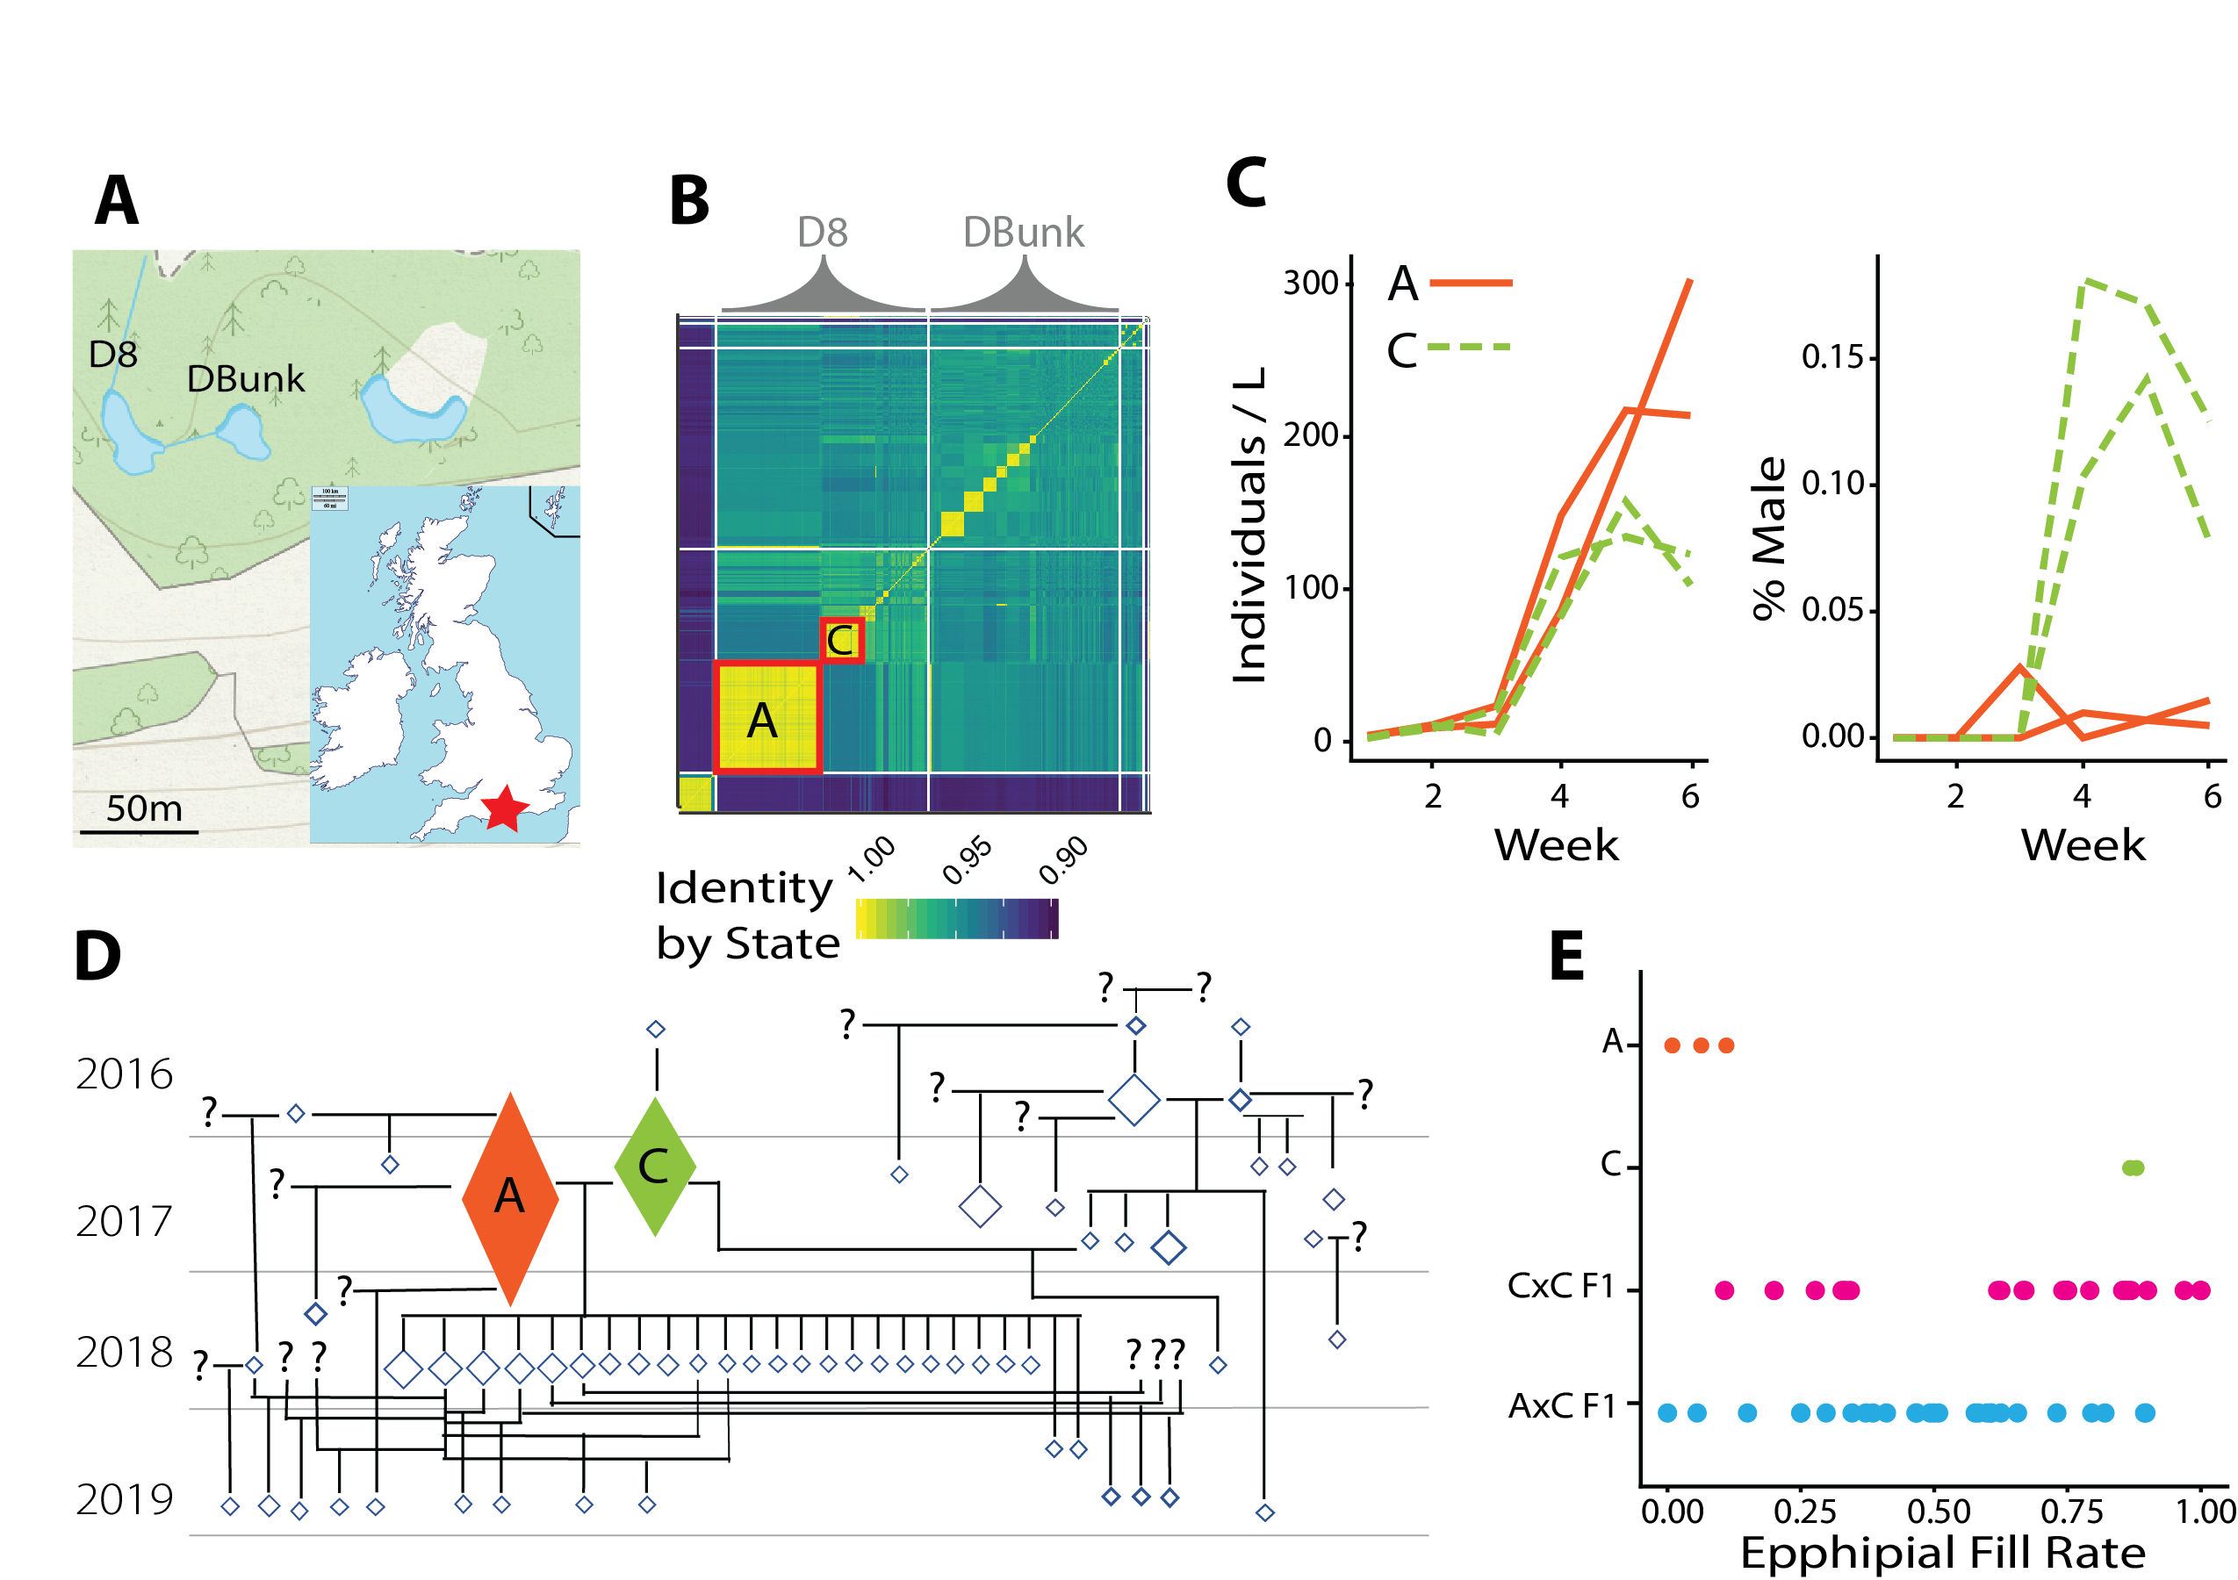

**Figure 2.** (A) Map of field site. Here, we highlight two ponds D8 and DBunk; we have been sampling from 6 additional ponds in this area (not all shown). (B) Genomic identity by state matrix for sequenced individuals. Large yellow blocks are dominant lineages; A and C are noted. (C) Lineages A and C invest differentially into reproductive mode. Each line is a replicate field isolate of either A or C. (D) Pedigree of D8 individuals inferred from kinship, IBS0, IBS1, and IBS2. Size of diamond is proportional to the number of sampled individuals (smallest diamonds are singletons). Self-fertilization events are represented by a single diamond with line below. (E) There is segregating variation in epphipial fill rate (a proxy for male production) between A and C, as well as amongst selfed-Cs. Each point represents the mean fill rate of a clone. Clones were generated in the lab (CxC; AxC) as well as from field samples (AxC).

Two dominant clonal lineages sampled from one pond in 2017 (Fig 2) exhibit variation in male production rate (~2% vs 15% of total brood), which leads to a significant difference in population growth rates (*R0*)as measured in lab mesocosms. These lineages mate readily in the lab and field; additionally, the male-limited “A” lineage is able to produce clonal ephippia, whereas “C” has not been observed to do so. Polymorphisms in sexual allocation have been observed in other daphnid systems (Galimov *et al.* 2011), but a number of features of the populations we work with differ from previous models, providing us with a unique opportunity to study alternative evolutionary paths of a parallel evolutionary process. Notably, in another system, complete male limitation (i.e., obligate parthenogenesis) arises, recurrently, via introgression from a closely related sister species. Male limitation is therefore primarily driven by variation at one-locus, which behaves in a ZW-like fashion (Ye *et al.* 2019). In the populations that we study, we have identified that variation in male production rate is polygenic, with upwards of ~8 QTL on separate chromosomes segregating between field caught males and females. Neither the dominant lineages, nor these specific QTL, show any evidence of arising via hybridization with another species (although we cannot rule out, at the moment, an unknown ‘ghost’ lineage). Rather, these dominant lineages appear to be cousins, and we hypothesize that alleles contributing to male limitation arise *de novo* within populations. Ongoing work seeks to narrow the previously identified QTL using field-caught and lab generated AxC recombinant lineages, and to further examine the evolutionary history of these loci. Future work will use the empirical observations of ecology, population dynamics, and genetic architecture that we have generated to parameterize forward-genetic simulations in which to assess the stability and persistence-time of fitness related genetic variation. This work is important because it examines the forces that generate and maintain variation in a system where variation should be quickly lost due to consanguinity and clonal selection.

**Overview of Future Research Plans**. The work conducted over the last four years has led to the development of genomic, computational, and experimental resources to study the effects of fluctuating selection on the maintenance of variation. **We will build on these advances to directly relate patterns of heritable variation in fitness related traits to the strength of fluctuating selection and the persistence time of balanced polymorphism**. This work will take place across a range of environmental conditions, in both lab and field-based settings, and will continue to layer quantitative genetic insight with population genetic inference.

***Drosophila***. Despite ample evidence of seasonal adaptation from phenotypic and genomic analysis (discussed above and in Biosketch), many features of this system remain unresolved. Notably, we lack a set of gold-standard true-positive loci that contribute to seasonal adaptation. As a consequence, it remains challenging to assess the consequence of adaptive tracking on patterns of genetic variation at linked sites or to assess the strength and predictability of seasonal adaptation at any given site. More generally, across most taxa, the magnitude and genomic extent of adaptive response to fluctuating selection pressures remains unknown. Technical challenges might limit inference of the strength of selection based on population allele frequencies alone (Buffalo & Coop 2019; Lynch *et al.* 2020) and unknown demographic factors many also affect inference of wild populations. Mapping experiments, as described in *Recent Progress*, can help identify specific loci associated with seasonal adaptation but the success of such edeavors might be restricted to oligogenic traits. Therefore, **experimental quantitative genetic approaches which seek to quantify the heritability and estimate the magnitude of genetic variance components may offer an attractive alternative to study the temporal dynamics of seasonal adaptation**.

To advance our understanding of the strength of selection and the magnitude of adaptive response to seasonally fluctuating environments, we will perform overwintering truncation selection experiments to estimate the strength of selection on heritable variation in gene expression. The experiment utilizes the breeder’s equation or its multivariate equivalent (Lande 1979), to calculate the strength of selection [*S*], with knowledge of heritability [*h2*] and the phenotypic response to selection [*R*]. The basic logic of this experiment is as follows: Using a Hybrid Swarm design, derived from inbred lines collected along the East Coast, we can accurately estimate *h2* of a trait using a genetic relationship matrix (Yang *et al.* 2010) estimated from genome-reconstructions (described above). If we measure the mean phenotype of the population in the generation before and the generation(s) after a selective event, we can estimate the response to selection (*R*). We can apply this technique to study the strength of selection across the transcriptome to obtain a more generalized and unbiased understanding of the distribution of selection and the magnitude of adaptive response to short term fluctuations in selection pressure. By conducting these truncation selection experiments in the lab (e.g., in response to freezing; Stone *et al.* 2020) and in the field (e.g., overwinter in outdoor mesocosms), **we can experimentally validate that seasonally varying selection is, indeed, operating in these populations and gain insight into the adaptive responses to specific selective events**.

This approach could either examine gene-expression taken across a single whole animal, or a specific tissue type (e.g., the head). We have successfully extracted RNA- and DNA- from single individuals (Weller et al, in prep), and it is even likely that we can reconstruct accurate genomes via RNA seq data alone. Low-cost RNA-seq libraries will be made using BRB-seq (Alpern *et al.* 2019). Note, that because the goal of these experiments is to measure components of variation we will only require, maximally, on the order of 1000-2000 individuals phenotyped and genotyped, as estimation of heritabilities based on GRM approaches are accurate with a limited number of individuals (Visscher & Goddard 2015). Although detecting eQTL is not the main purpose of these experiments, regions of the genome associated with heritable variation in gene expression can be identified using mixed effect modeling (Conomos *et al.*) or sparse linear models (Pérez & de los Campos 2014). This work will identify putative phenotypic targets of natural selection, and will elucidate aspects of the physiological and developmental basis of local adaptation.

***Daphnia***. Future work in Daphnia will examine the evolutionary outcomes of temporal variation in selection pressure. The goal of this work is to examine how seasonal cycles of clonal growth and sex lead to the evolution of polymorphism and to the evolution of plasticity / bet-hedging. By addressing these topics in Daphnia, we can test basic predictions (Botero *et al.* 2015) about the relationship between the predictability of environmental change on the evolution of these components of phenotypic variance.

First, we will continue our work studying the evolution of polymorphism in sexual investment. We will approach this work using both laboratory experiments and observational studies of natural populations. To experimentally test the evolutionary dynamics of sexual investment, we will conduct crosses within and between clonal lineages and compete these recombinant offspring in mesocosms. We will focus on the two clonal lineages that we have studied extensively which show polymorphism in male production rate (A and C, Figure 2), although we will also generalize this work by expanding analysis to other clones from the Dorset area, or elsewhere, when appropriate. Competition experiments will be seeded with ephippia derived from selfing and outcrossing of these parental clones, and we will track the frequency of recombinant clones through time using a combination of pooled and individual sequencing. These estimates of frequency directly relate to fitness. Note that sequencing effort for this type of experiment can be kept at a reasonable level because we have (or can easily generate) phased genomes for parental clones via trio-phasing (PattersonMurray *et al.* 2015; Choi *et al.* 2018). The distribution of fitness of recombinant offspring offspring will allow us to assess the consequences of inbreeding depression, determine whether fitness is affected by any over-dominant alleles (Charlesworth & Willis 2009), and whether experimental treatments dramatically alter the outcome of the evolutionary process. We will couple these experimental approaches with continued sampling and analysis of population genomic data from the Dorset populations. We will work to examine patterns of molecular evolution as they relate to the inferred pedigree and test whether loci involved in male limitation appear to arisen recently in these populations (via mutation or migration) or whether they have persisted in these populations for long periods of time. This analysis will take advantage of recent advances in ancestral recombination graph analysis (Rasmussen *et al.* 2014) and will couple the analysis of phased genome data with extensive forward simulation (Haller *et al.* 2019), parameterized by known ecological aspects of these ponds. This work is important because it will allow us to experimentally test the role of different ecological forces on the maintenance of genetic variation in this species.

The second major Daphnia project that we will pursue examines apparent bet-hedging in the requirement of vernalization for ephippial hatching. Examination of hatching patterns in lab generated crosses shows that ~30% of ephippia spontaneously hatch without any vernalization cue; the remainder require a combination of cold temperatures and dark, followed by exposure to light and warmth to hatch. In other Daphnia populations, vernalization is required for any hatching (Luu *et al.* 2020), and the appearance of spontaneous hatching likely reflects the adaptation driven by the ecology of the ponds. The ponds in Dorset dry periodically and likely stochastically from year to year, plausibly (Graham *et al.* 2014) leading to local adaptation in bet-hedging (Simons 2009). To advance our understanding of the biology of vernalization, we will first assess phenotypic genetic variation in spontaneous hatching between ponds that vary in ephemerality. We will follow up this work by via bulk segregant analysis of F1 (or more advanced generations, when appropriate) crosses between clones that show variation in vernalization requirement. We will address the prevalence of maternally deposited cues through the use bisulfite sequencing of freshly deposited embryos in order to determine whether maternal modification of methylation state is correlated with the rate of spontaneous hatching (Harris *et al.* 2012). This work will advance our understanding of basic aspects of Daphnia genetics and biology and will also provide insight into the adaptive dynamics of bet-hedging.

**Future directions**. Future work in Drosophila will study the role of local meta-population dynamics (e.g., seasonal recolonization (Shpak *et al.* 2010)) on the dynamics and patterns of seasonal evolution. This work will allow us to address the role of spatial refugia in the maintenance of genetic variation and the role of founder effects in the outcome of strong selection in quantitative traits. Future work in Daphnia will characterize the molecular genetics of polymorphism in male production, and will utilize RNAi (Hiruta *et al.* 2013) and CRISPR (Hiruta *et al.* 2018)